**Superstore Sales & Profit Insights**

**Measures and Visuals – Superstore Dataset**

Prepared by: Nithin Garalapati

Date: July 2025

# Objective

The objective of this assignment is to analyze the Superstore dataset using Power BI by creating various visuals, calculated columns, and DAX measures to understand sales trends, profit distribution, and regional performance. The report also includes key performance indicators (KPIs), comparison charts, and advanced Power BI visuals.

# Dataset Description

The dataset used is the 'Superstore' dataset, containing information on orders, categories, sub-categories, sales, profit, discounts, quantities, customer locations, and more. It is commonly used in data visualization projects.

# 1. Line Chart – Monthly Sales Trend

This visual shows the trend of sales over months to analyze seasonality and growth.

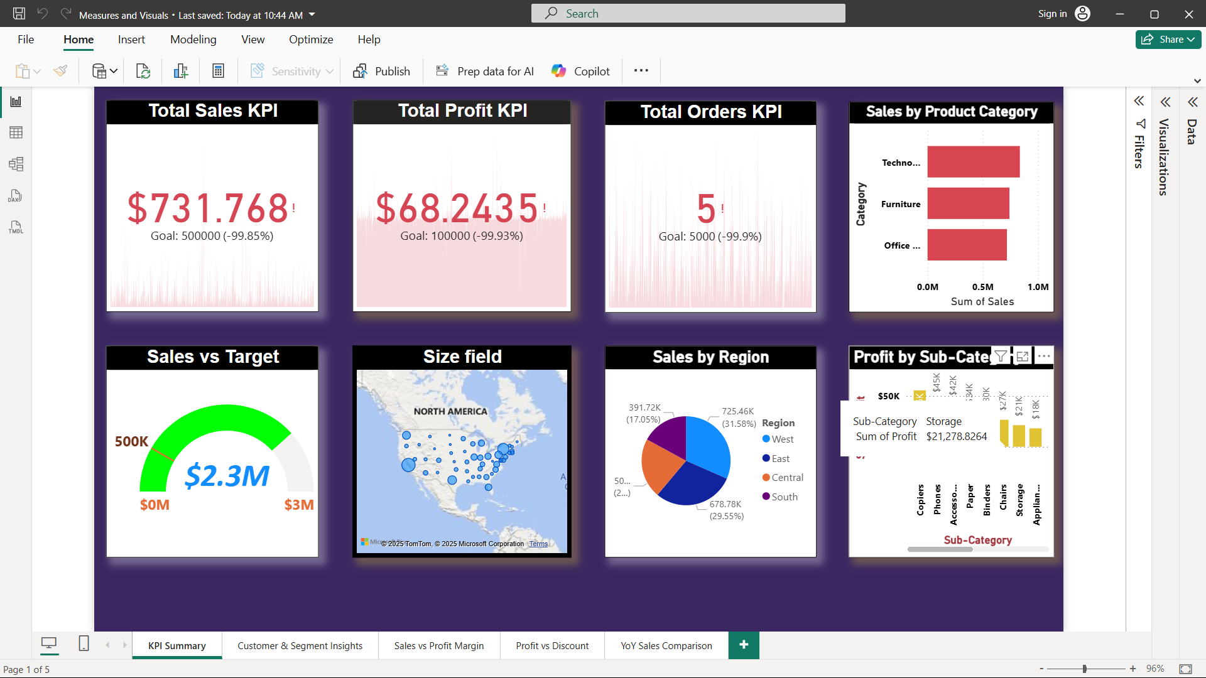

# 2. Combo Chart – Sales vs Profit Margin

Displays both Sales and Profit Margin across months using a combination of bar and line chart.

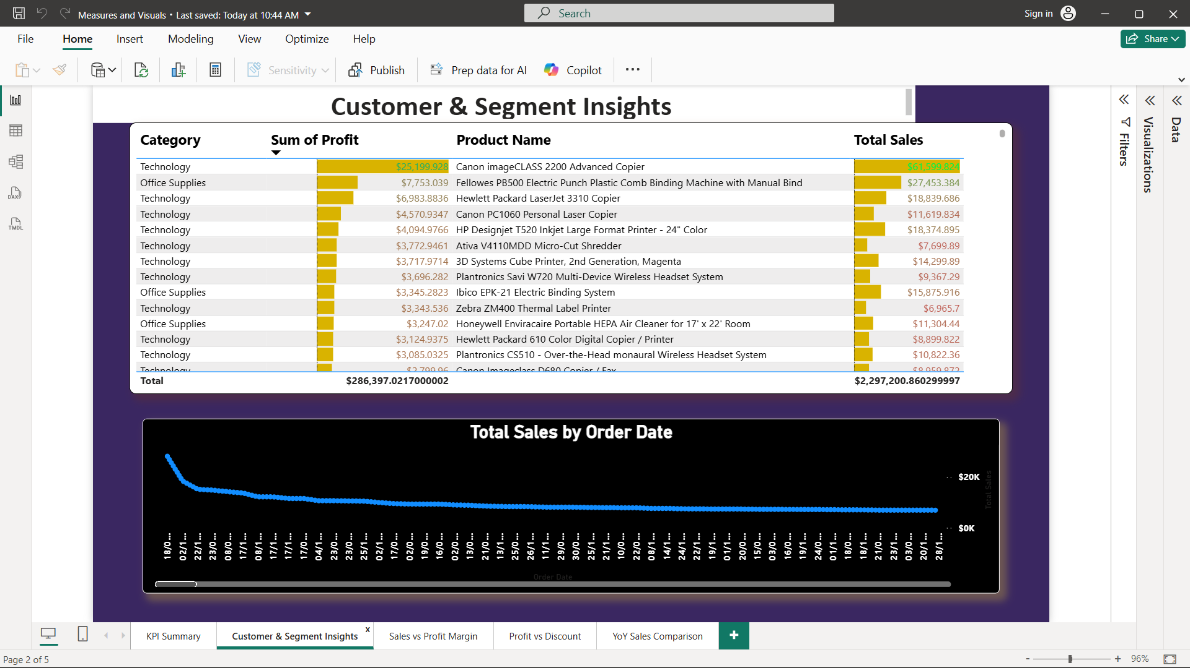

# 3. Scatter Plot – Profit vs Discount

Helps understand the relationship between discount given and the resulting profit.

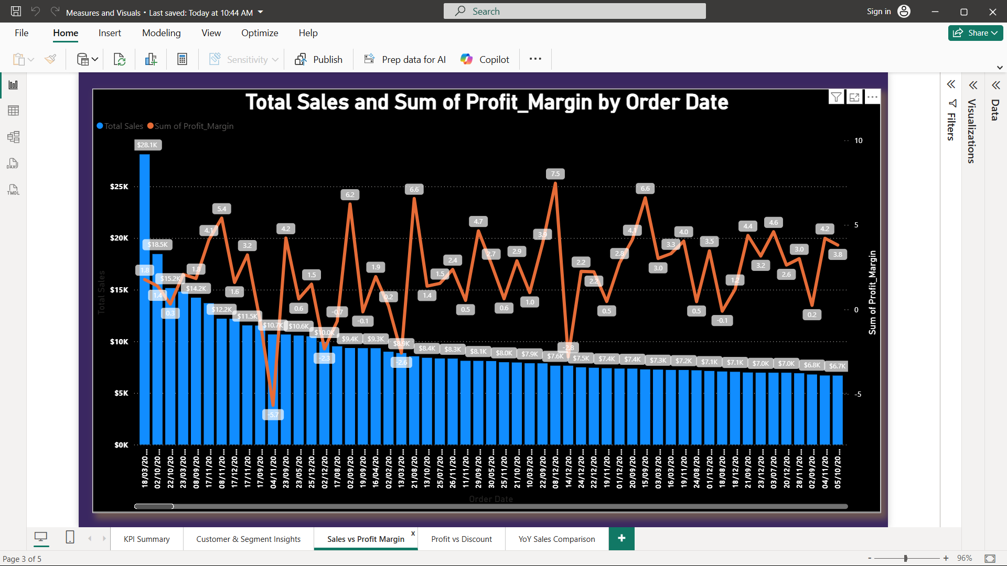

# 4. Year-over-Year Sales Comparison

This bar chart compares total sales from the current year and the previous year side by side.

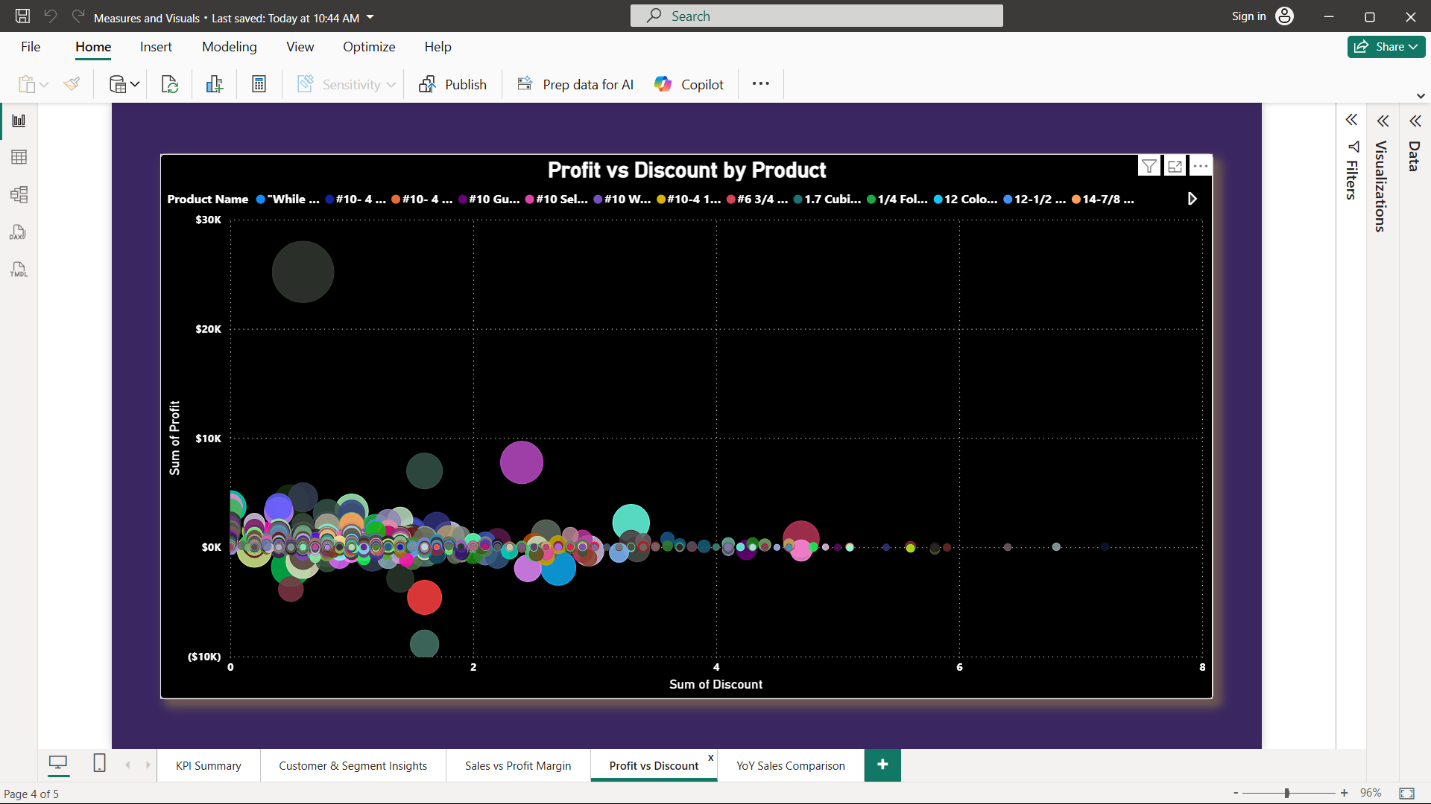

DAX Measure – Current Year Sales:

CurrentYearSales =   
CALCULATE(  
 SUM(Superstore[Sales]),  
 YEAR(Superstore[Order Date]) = 2022  
)

DAX Measure – Previous Year Sales:

PreviousYearSales =   
CALCULATE(  
 SUM(Superstore[Sales]),  
 YEAR(Superstore[Order Date]) = 2021  
)

# 5. KPI – Total Sales

A Key Performance Indicator visual to highlight the overall sales figure.

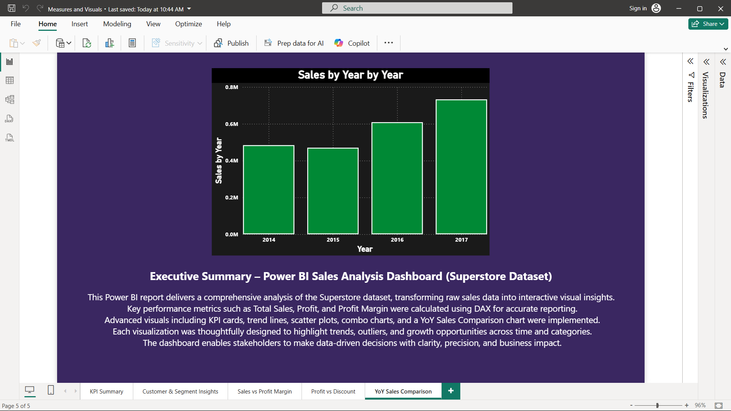

# 6. Gauge Chart – Profit Margin

A gauge visual shows how close the actual profit margin is to the target.

[Insert Screenshot of Gauge Chart Here]

# 7. Map – Sales by State

Displays geographic distribution of sales across various states.

[Insert Screenshot of Map Here]

# Summary

This assignment demonstrates how to use Power BI for insightful visual analytics. Using DAX measures and various chart types, we explored trends, performance, and relationships within the Superstore dataset. The use of KPIs and YoY comparisons enhances decision-making capabilities.

GitHub Repository: [[Github link](https://github.com/PNG-NITHIN/Power-BI-Visual-Analytics-Sales-Performance-Dashboard-Superstore-Dataset-)]